# PRO-C179

CURRENT LOCATION & QUERY PARAMETERS

# What is our GOAL for this MODULE?

We learned to write JavaScript functions to get the current location of the user and use query parameters to pass data from one page to the other.

# What did we ACHIEVE in the class TODAY?

● We learned to write JavaScript functions to get the current location of the user.

● We learned to use query parameters to pass information from one page to another.

# Which CONCEPTS/CODING BLOCKS did we cover today?

● navigator.geolocation.getCurrentPosition

● $(document).ready()

● map.addControl()

● on click function

● window.location.href, window.location.search, URLSearchParams(), window.history.back

● split() String method

1. Create a function init Geolocation()in main.js file.

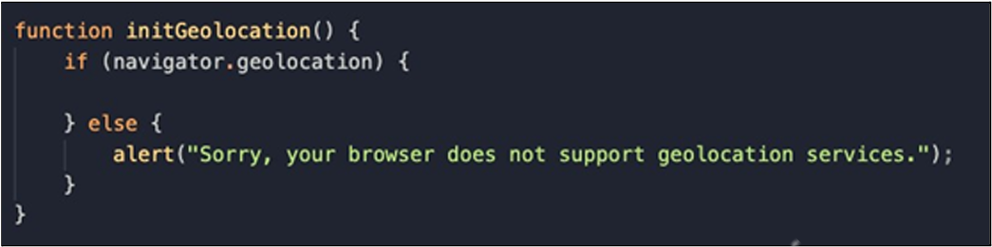

1. If the getCurrentPosition() works properly and is able to get the user’s location, it will call the success() function in which it will provide the user’s current position as an argument.

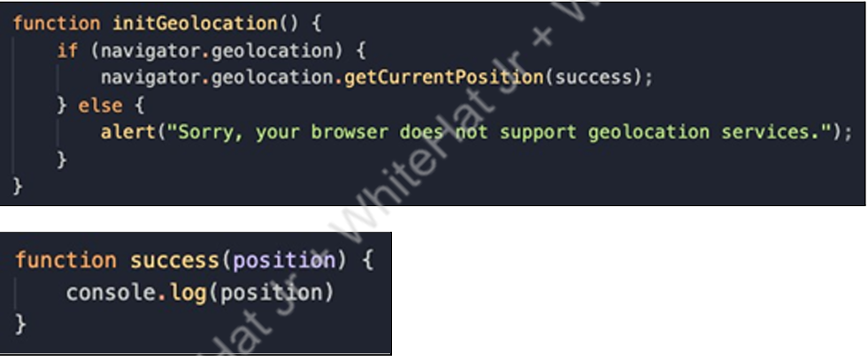

1. Call the function init Geolocation(), open in the browser and check the console.

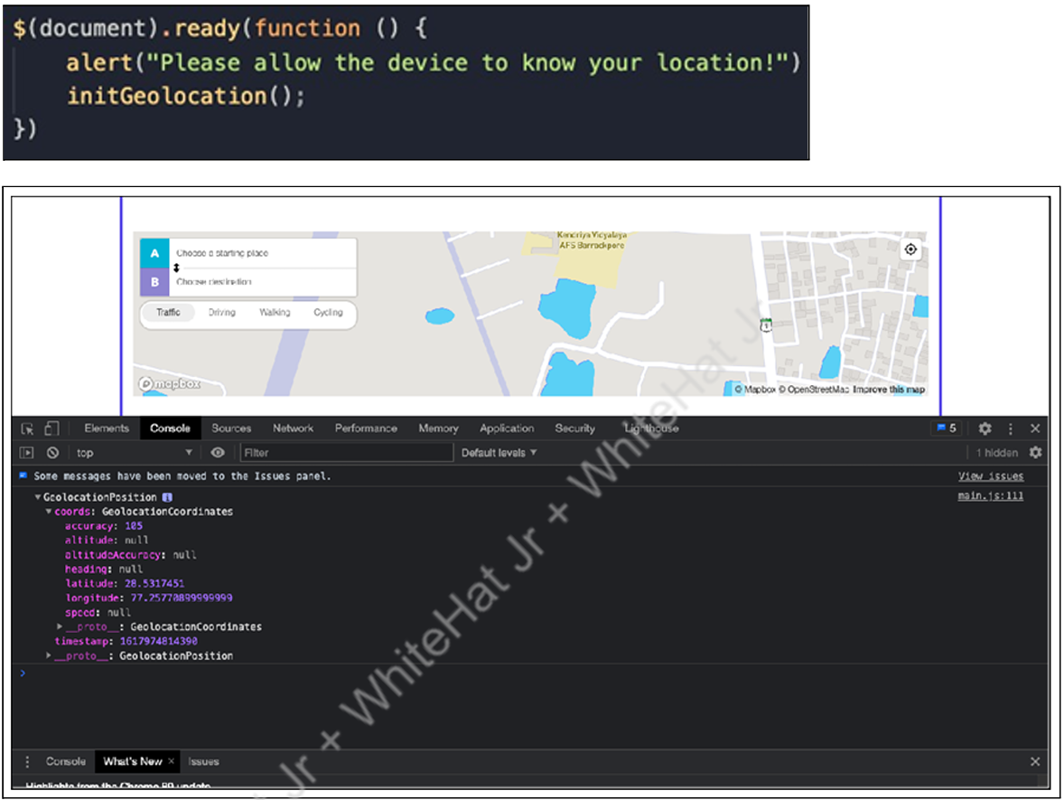

1. Give values to our latitude and longitude from the position argument in the success() function and then move all code for Mapbox inside this success() function.

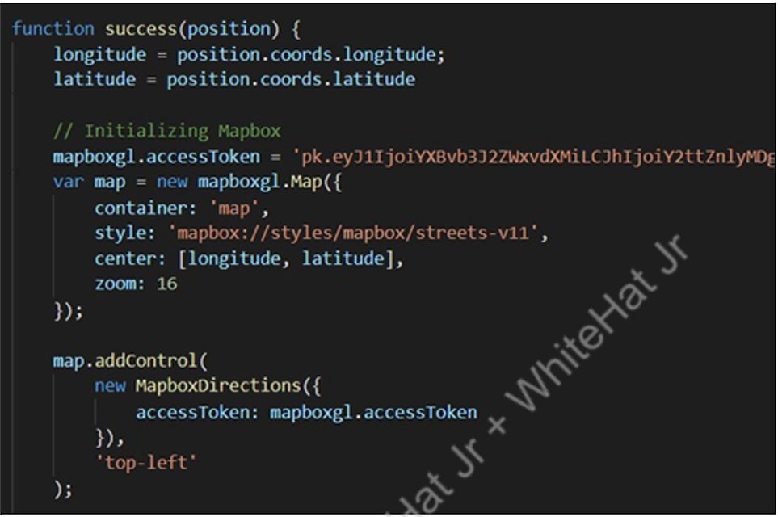

1. Inside our success() function, let’s add an on click function.

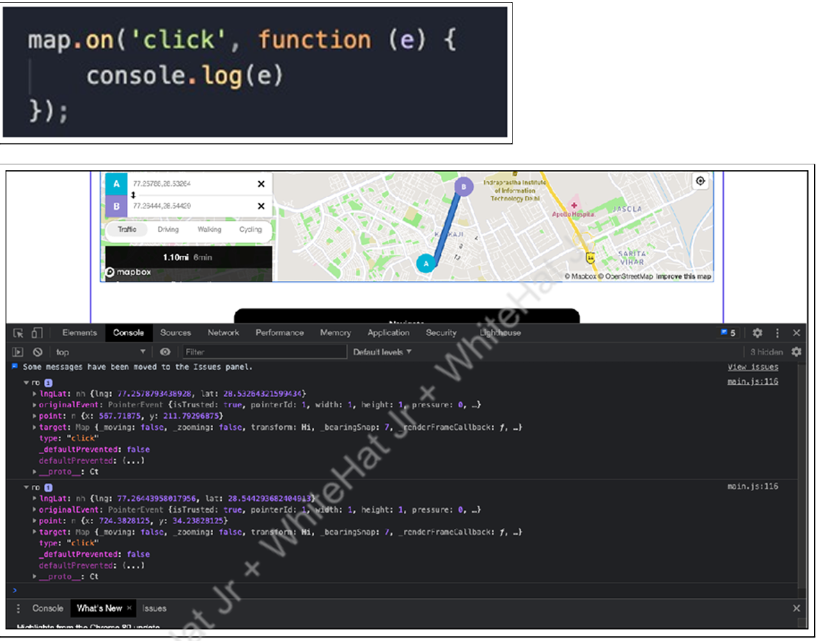

1. Create a click() event function on our navigate button.

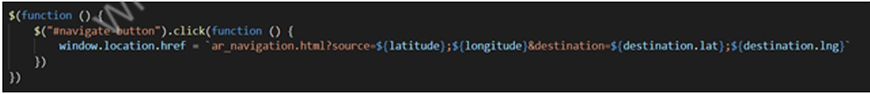

1. Create ar_navigation.html for the next screen and corresponding files for it ar_navigation.js and ar_navigation.css.

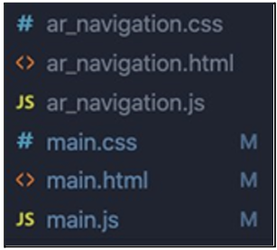

8. To fetch the source and destination coordinates from the query parameters:

● Create an object called coordinates in which we will be saving the coordinates for our starting point and destination.



● Create a $(document).ready() function where we will call a function that can fetch the coordinates.

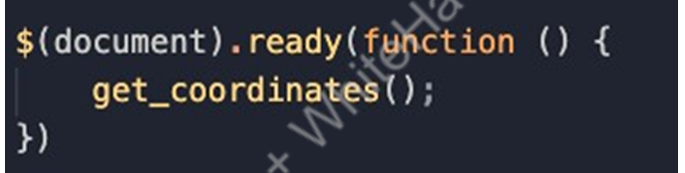

● Create get_coordinates() function to get the data from the query parameters.

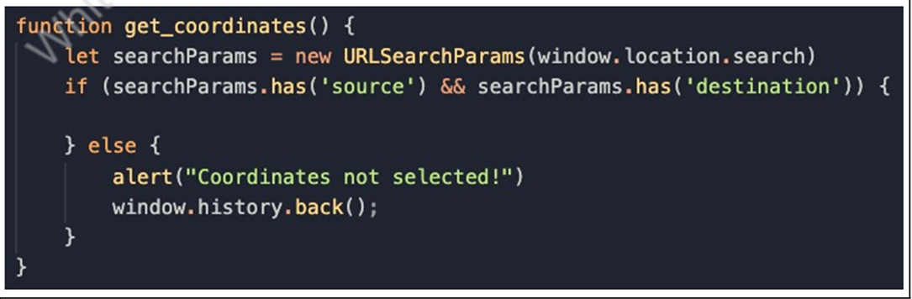

● After getting the source and destination parameters, with the help of split() function, we are saving the source_lat, source_lon, destination_lat and destination_lon values in our coordinates object.

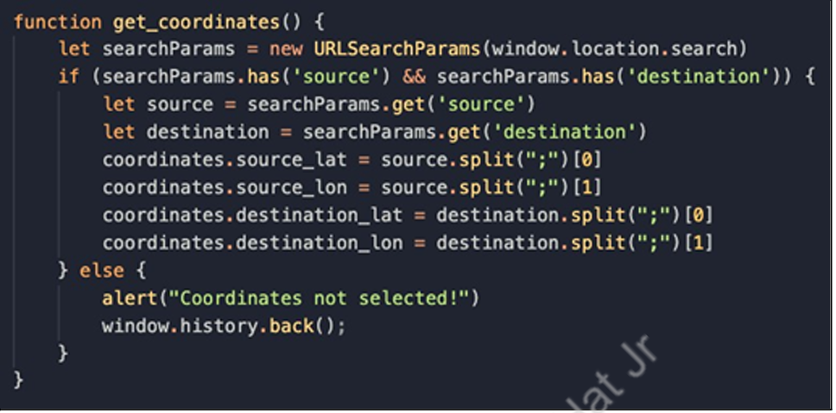

We have successfully fetched our source and destination coordinates from the query

parameters.

# What’s NEXT?

In the next class, we will learn about location based Augmented reality.

# EXTEND YOUR KNOWLEDGE:

● You can refer to the link below to explore more about AFrame A-Frame.

● You can refer to the link below to explore more about jQuery jQuery.

● You can refer to the link below to explore more about jQuery jQuery.

● You can refer to the link below to explore more about Navigator Object Navigator